Test Results
Samples Taken - 4/30/97
In both studies, the air inside the home contained less fungus than the air outside.
Main Floor Ambient Air Samples
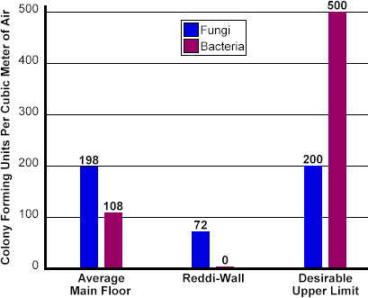

Basement Air Samples
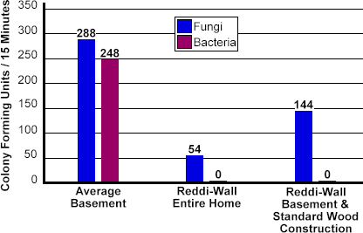

The preceding studies were performed for us by Sanit-Air and Environmental Compliance Solutions, located at 966 Livernois, Troy, MI 48083. We would strongly recommend them to anyone in need of indoor air quality testing or for advice on complying with environmental regulations.

